Exercise 1
To create a code group, you need to perform the following steps:
- Open the Microsoft .NET Framework 2.0 Configuration tool.
- Expand the Runtime Security Policy node and then expand the Machine node for the policy level to be added in the code group.
- Expand the Code Groups node, and then expand the All_code node to view the tree under it.
- Right-click the code group that will be the immediate parent of the new code group, and choose the New option, as shown in the following figure.

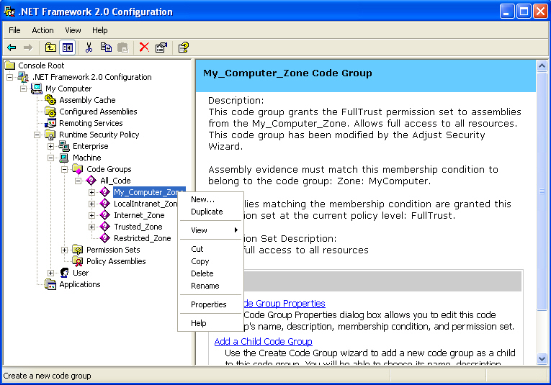
Creating a New Code Group
- Provide a name to the code group in the Create Code Group dialog box that appears, and click the Next button, as shown in the folowing figure.
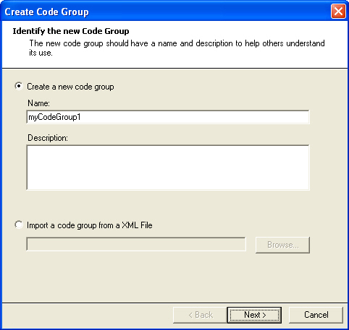
Identify the New Code
- Select a membership condition from the drop-down list and follow the instructions for entering the requested information for the membership condition, and then click the Next button, as shown in the following figure.
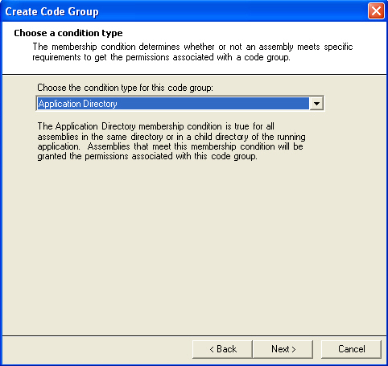
Choosing a Condition Type
- Choose an existing permission set from the drop-down list or select Create a new permission set, and then click the Next button, as shown in the following figure.
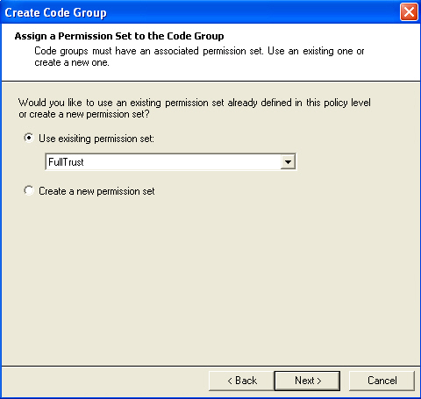
Assigning a Permission Set to a Group
- The Completing the Wizard screen appears. Click the Finish button in the Completing the Wizard screen, as shown in the following figure.
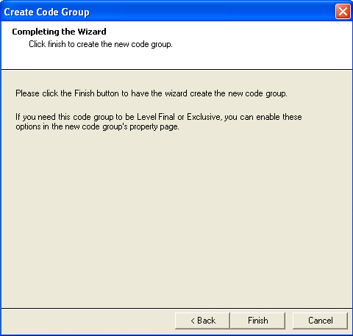
Completing the Wizard Page
The newly added code group appears in the treeview in the left pane of the .NET Framework 2.0 Configuration tool window, as shown in the following figure.
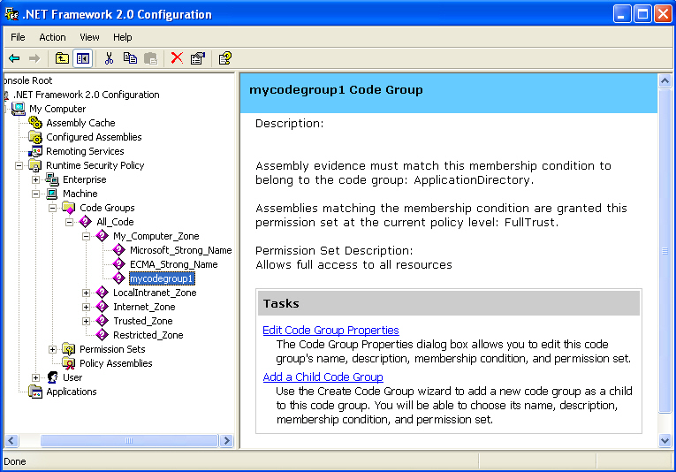
The Newly Created Code Group

Exercise 2

The various trust levels of the CAS model are:
- Full Trust: Security checks are not performed and programs can access and use all the resources on your machine.
- Medium Trust: Programs cannot access the most protected resources such as the registry or security policy settings. In addition, programs cannot access the local file system without user interaction. Programs can connect back to their site of origin, resolve domain names, and use all Windows resources.
- Low Trust: Programs cannot access protected resources such as the registry, environment variables, domain names, or security policy settings. Programs have limited ability to use windowing resources and your local file system.
- No Trust: Programs are not allowed to execute.

